Calvary Awana
Grand Prix Rules and Regulations
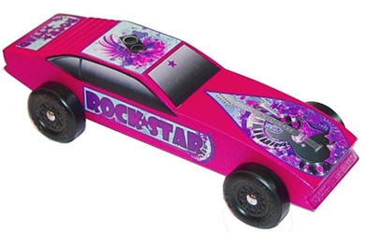

General Rules
▪ All cars must be constructed from an Official Awana Grand Prix Kit. Do
not use kits from the hobby store.
▪ Only one car may be registered by any person in the Awana Grand Prix.
▪ Each car must pass a Technical Inspection before it may compete.
o The judges may disqualify cars that do not meet the rules as described herein. If the car does not pass inspection, the owner will be informed of the reason.
o Cars that fail inspection may be modified and brought back before the registration table closes for final inspection.
o No car may be altered in any way after it has been registered.
▪ After a car passes registration; it will be stored by a Grand Prix Official on a display table.
▪ All interpretations of the rules are at the sole discretion of the Inspection and Registration Judges.
- It is expected that clubbers will need and use adult help in the construction and completion of their car.
- It is expected that all contestants will exhibit good sportsmanship before, during and after the event.

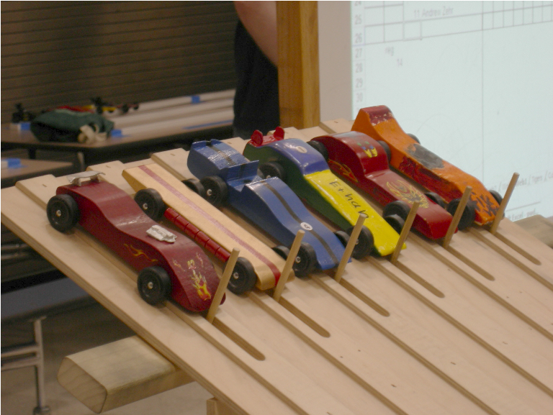
Construction Standards
▪ All cars must have been made during the current year (the year in
which the derby is held, i.e., since September).
▪ The width of the car shall not exceed 2 ¾ inches and the length shall
not exceed 7 inches.
▪ The weight of the car shall not exceed 5 ounces.
▪ Underside clearance of at least 3/8 inches and wheel-to-wheel
clearance of at least 1 ¾ inches is recommended.
▪ The car shall roll on the wheels from the kit. The axle nails shall be
firmly fixed on the car body, and must be placed in the original
axle groves in the supplied wooden block.
▪ Axles, wheels, and body wood shall be provided in the kit.
▪ Solid axles, wheel bearings, washers, and bushings are prohibited.
▪ Wheels may not be modified other than to remove mold seams and similar burrs.
▪ No lubricating oil may be used. Axles may be lubricated with powdered graphite or silicone.
▪ The car shall not ride on any kind of springs.
▪ The car shall not be freewheeling or have any starting devices.
▪ No loose materials of any kind are allowed on the car.
o If weights or cosmetic pieces fall from the car during a race, they will not be put back onto the car.
o If a wheel falls from the car during a race and prevents it from crossing the finish line, it will be allowed to place 4th place in that race.
o Wheel repairs will be allowed by the clubber, but must be completed before its next race to continue.

